PENETRATION TESTING REPORT
FOOTPRINTING & NETWORK SCANNING PHASES
W2-PM-FINAL | CYBERSECURITY | NETWORKWALKS

Pentester Name  (Cybersecurity Professional) | Emmanuel John
Program/Batch | B084-Networkwalks
Date | 11 November 2026
Modules completed | W2-PM1 (Multiple Kali Tools)  W2-PM5 (Zenmap Scanning)
Client/Target | 1. Networkwalks (secured written permission already)  2. My own local LAN Network
Permission secured from client? | Yes
Phases covered | Phase 1: Reconnaissance & Footprinting  Phase 2: Scanning & Network Discovery  Phase 3-5: In Progress

1. Liability Disclaimer
I have performed these activities only on the systems & devices where I had secured written permission or the devices/systems that I own myself. All these materials are for education and research purpose only. Do not use anything from here to break the law. The instructor, the authors and Networkwalks are not responsible for what you do with this knowledge. Every action you take is your own responsibility. Misuse can lead to criminal charges, heavy fines, loss of your job and a permanent record. In most countries unauthorised access is a crime even when nothing is damaged.

2. Introduction
This report covers footprinting the networkwalks.com domain using multiple Kali Linux tools (W2-PM1) and scanning my own local network with Zenmap (W2-PM5). One module covers the footprinting phase and the other covers the scanning phase, so together they show how an attacker moves from gathering public information to mapping live hosts on a network. It is the Week 2 part of my ongoing internship program at Networkwalks.
All commands were run in Kali Linux (footprinting) and on a Windows PC with Zenmap installed (scanning). Every step below includes the exact command used, the result I observed, a screenshot as evidence, and a short note on why the finding matters from an attacker's point of view.

3. Tools Used
The table below lists each tool used in this report and its purpose.
Tool | Platform | Core Purpose / Function
Kali Linux & Windows | Operating System | Host environments used for footprinting and scanning activities
WHOIS | Kali Linux | Retrieve domain registration metadata, creation/expiration dates, and name servers
WhatWeb | Kali Linux | Fingerprint web technologies, server software, CMS versions, and plugins
Nslookup | Kali Linux | Perform DNS queries to resolve the target domain name to its IPv4 address
Curl (-I) | Kali Linux | Read raw HTTP response headers to inspect web application configuration
Wafw00f | Kali Linux | Identify Web Application Firewall (WAF) presence and specific security vendors
DNSRecon | Kali Linux | Enumerate DNS records including NS, MX, TXT/SPF, and autodiscovery SRV records
Zenmap (Nmap GUI) | Windows PC | Scan the local subnet range to discover active hosts, IP addresses, MAC addresses, and topology
Windows Command Prompt | Windows PC | Run ipconfig to identify local host IP address and determine LAN subnet mask

4. Activities Performed

4.1 Footprinting & Reconnaissance (Module W2-PM1)
I performed reconnaissance against the networkwalks.com domain using six Kali Linux tools: WHOIS, WhatWeb, Nslookup, Curl, Wafw00f, and DNSRecon. Each tool was used to collect a different type of information about the target.

Activity 1: Domain Registration Footprinting (WHOIS)
- Command Executed:
Bash
whois networkwalks.com
- Technical Description: I used WHOIS to obtain publicly available domain registration information, registrar metadata, creation/expiration timelines, and primary domain name servers.
- Observation & Findings: The query successfully returned administrative contact references and authoritative name servers for the target infrastructure.

Activity 2: Web Technology Fingerprinting (WhatWeb)
- Command Executed:
Bash
whatweb networkwalks.com
- Technical Description: I used WhatWeb to analyze web application headers, HTML source signatures, and embedded scripts to identify underlying software stacks.
- Observation & Findings: The scan identified WordPress content management system, underlying server stack details, and active plugin extensions.

Activity 3: Public IP Resolution (Nslookup)
- Command Executed:
Bash
nslookup networkwalks.com
- Technical Description: Using Nslookup, I performed forward DNS resolution against public name servers to resolve the domain to its IPv4 destination.
- Observation & Findings: The domain successfully resolved to public hosting IP address 192.232.216.135.

Activity 4: HTTP Response Header Inspection (Curl)
- Command Executed:
Bash
curl -I networkwalks.com
- Technical Description: I executed Curl with the -I flag to fetch HTTP response headers without downloading full web page body contents.
- Observation & Findings: The output revealed web server response headers (Apache), HTTP 301 redirection rules, and exposed REST API endpoints (/wp-json/).

Activity 5: Web Application Firewall Detection (Wafw00f)
- Command Executed:
Bash
wafw00f networkwalks.com
- Technical Description: I executed Wafw00f signature probes against the web server to determine whether traffic was passing through a protective security gateway.
- Observation & Findings: The scan positively identified ModSecurity (SpiderLabs) Web Application Firewall actively protecting the web server.

Activity 6: Comprehensive DNS Enumeration (DNSRecon)
- Command Executed:
Bash
dnsrecon -d networkwalks.com
- Technical Description: I ran DNSRecon to perform automated enumeration of all published DNS zone records associated with the domain.
- Observation & Findings: The tool enumerated Name Servers (NS), Mail Exchanger records (MX), SPF/TXT verification strings, and autodiscover SRV service points.

4.2 Network Scanning with Zenmap (Module W2-PM5)
For the second activity, I used Zenmap to perform network discovery on my local network. The practical required me to identify my local IP address and subnet, discover live hosts, identify their IP and MAC addresses, and generate a network topology.

Activity 1: Local Subnet Identification (Ipconfig)
- Command Executed:
DOS
ipconfig
- Technical Description: I executed ipconfig within Windows Command Prompt to inspect active network adapter interfaces.
- Observation & Findings: My active Wi-Fi interface was configured with IPv4 Address 10.169.157.186 under Subnet Mask 255.255.255.0, yielding local target range 10.169.157.0/24.

Activity 2: Subnet Host Discovery (Zenmap Intense Scan)
- Target Entered: 10.169.157.0/24
- Profile Selected: Intense scan
- Technical Description: I initiated an Intense Scan in Zenmap across the subnet range to discover active hosts, open ports, MAC addresses, and operating system signatures.
- Observation & Findings: Zenmap discovered live hosts on the subnet (including 10.169.157.40 running Android OS/dnsmasq services and active network interface 10.169.157.186), completing with status "Nmap done".

Activity 3: Network Topology Map Generation
- Technical Description: Following scan completion, I switched to Zenmap's Topology tab to analyze physical node placement and routing relationships.
- Observation & Findings: Zenmap generated a visual graph illustrating host positions, gateway hops, and network nodes relative to the scanning system.

5. Risk Analysis / Impact
Based on the information collected during the footprinting and network scanning activities, I identified the following potential risks.
# | Risk / Finding | Evidence / Observation | Potential Impact | Risk Level
1 | Web technology information exposed | WhatWeb identified WordPress and WP Download Manager details | Attackers may use exposed technology/version information to identify software requiring further security review | Medium
2 | Server IP address identifiable | Nslookup resolved the domain to 192.232.216.135 | Provides information about the network location of the web service | Low
3 | HTTP technical information exposed | Curl returned HTTP response headers and exposed /wp-json/ | May assist technology fingerprinting and further enumeration | Low
4 | WAF technology identifiable | Wafw00f identified ModSecurity (SpiderLabs) | Reveals information about the web application’s security architecture | Low
5 | DNS infrastructure information exposed | DNSRecon identified DNS, mail and service-related records | DNS information can help build a broader infrastructure profile | Medium
6 | Multiple live hosts visible on local network | Zenmap identified active hosts across the local subnet | Unknown or unauthorized devices may potentially be present on a network | Medium
Risk level key: Critical | Medium | Low
The risks above are observations from the footprinting and scanning exercises, not confirmed vulnerabilities. The practical exercises primarily involved information gathering and host discovery. No exploitation or vulnerability validation was performed as part of these two modules. Therefore, the presence of information such as a software version, IP address or DNS record does not by itself mean that the system is vulnerable. Further authorized security testing would be required to confirm any actual vulnerability.

6. Recommendations
Based on the observations from these activities, I recommend the following security improvements:
- Review publicly exposed technology information: Organizations should regularly review what information about their web technologies, CMS and plugins is publicly visible.
- Keep software updated: CMS platforms, plugins and other web technologies should be regularly updated and reviewed against current security advisories.
- Review HTTP headers: HTTP response headers should be reviewed to determine whether unnecessary technical information is being exposed.
- Review DNS records regularly: DNS records should be checked periodically to ensure that only required information and services are publicly exposed.
- Properly configure and monitor the WAF: Keep the WAF (ModSecurity) enabled and tuned, since it already blocks naive attacks.
- Perform regular internal network discovery: Organizations should periodically scan their own networks to identify active devices.
- Investigate unknown devices: Any unexpected device discovered during network scanning should be investigated and verified.
- Maintain network documentation: Network topology and device information should be documented and updated regularly.
- Perform security testing with authorization: Reconnaissance and scanning should only be performed against systems and networks where appropriate authorization has been provided.

7. Conclusion
During Week 2 of my Cybersecurity & Ethical Hacking internship, I completed practical activities covering footprinting, reconnaissance and network scanning.
In the footprinting activity, I used six Kali Linux tools to collect information about the target domain. I learned how WHOIS can provide domain information, WhatWeb can identify web technologies, Nslookup can resolve domain names, Curl can inspect HTTP headers, Wafw00f can identify a WAF, and DNSRecon can provide additional DNS information.
In the network scanning activity, I used Zenmap to identify my local network configuration and discover active hosts. I also collected IP and MAC address information and created a network topology.
The exercises showed me that information gathering is an important part of cybersecurity. Even before attempting to exploit a system, a security professional can learn a significant amount about an environment by carefully analyzing publicly available information and network responses.
I also learned that technical findings should be documented clearly. A good cybersecurity report should explain what was performed, what was discovered, what the observation means, what risk it may create, and what can be done to reduce that risk.
Finally, I learned that reconnaissance and scanning must always be performed within an authorized scope. These activities were completed as part of the assigned educational cybersecurity lab.

8. Evidences Collected

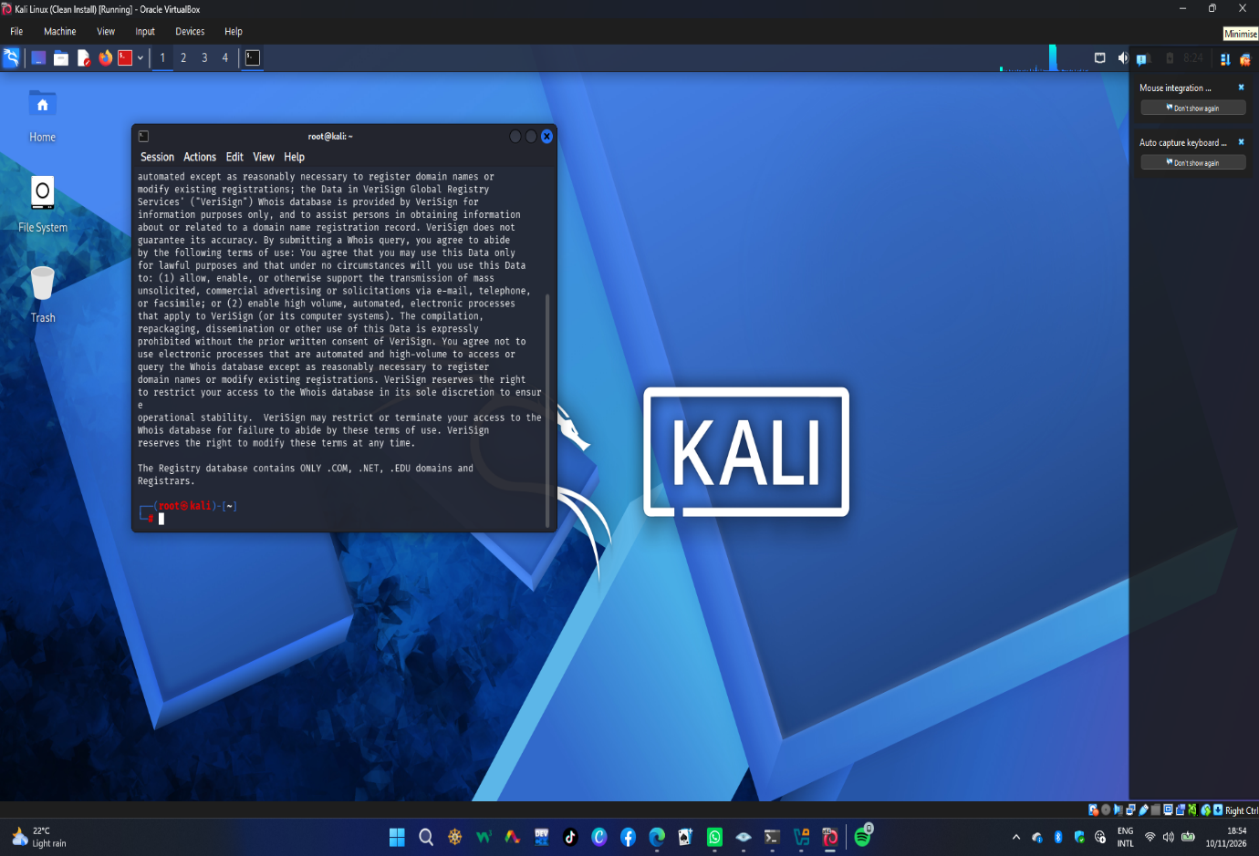

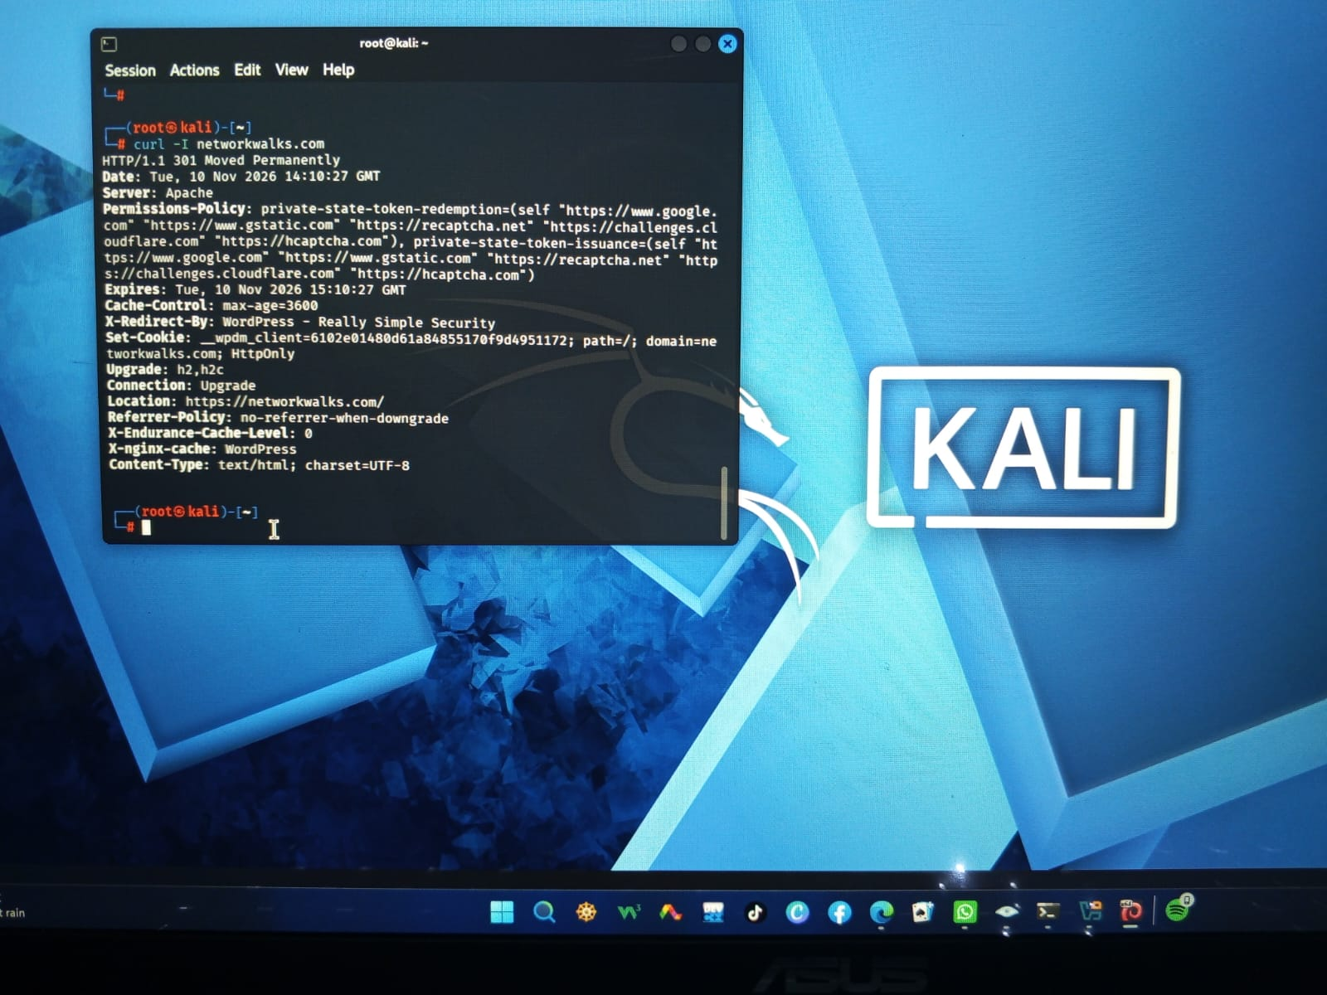

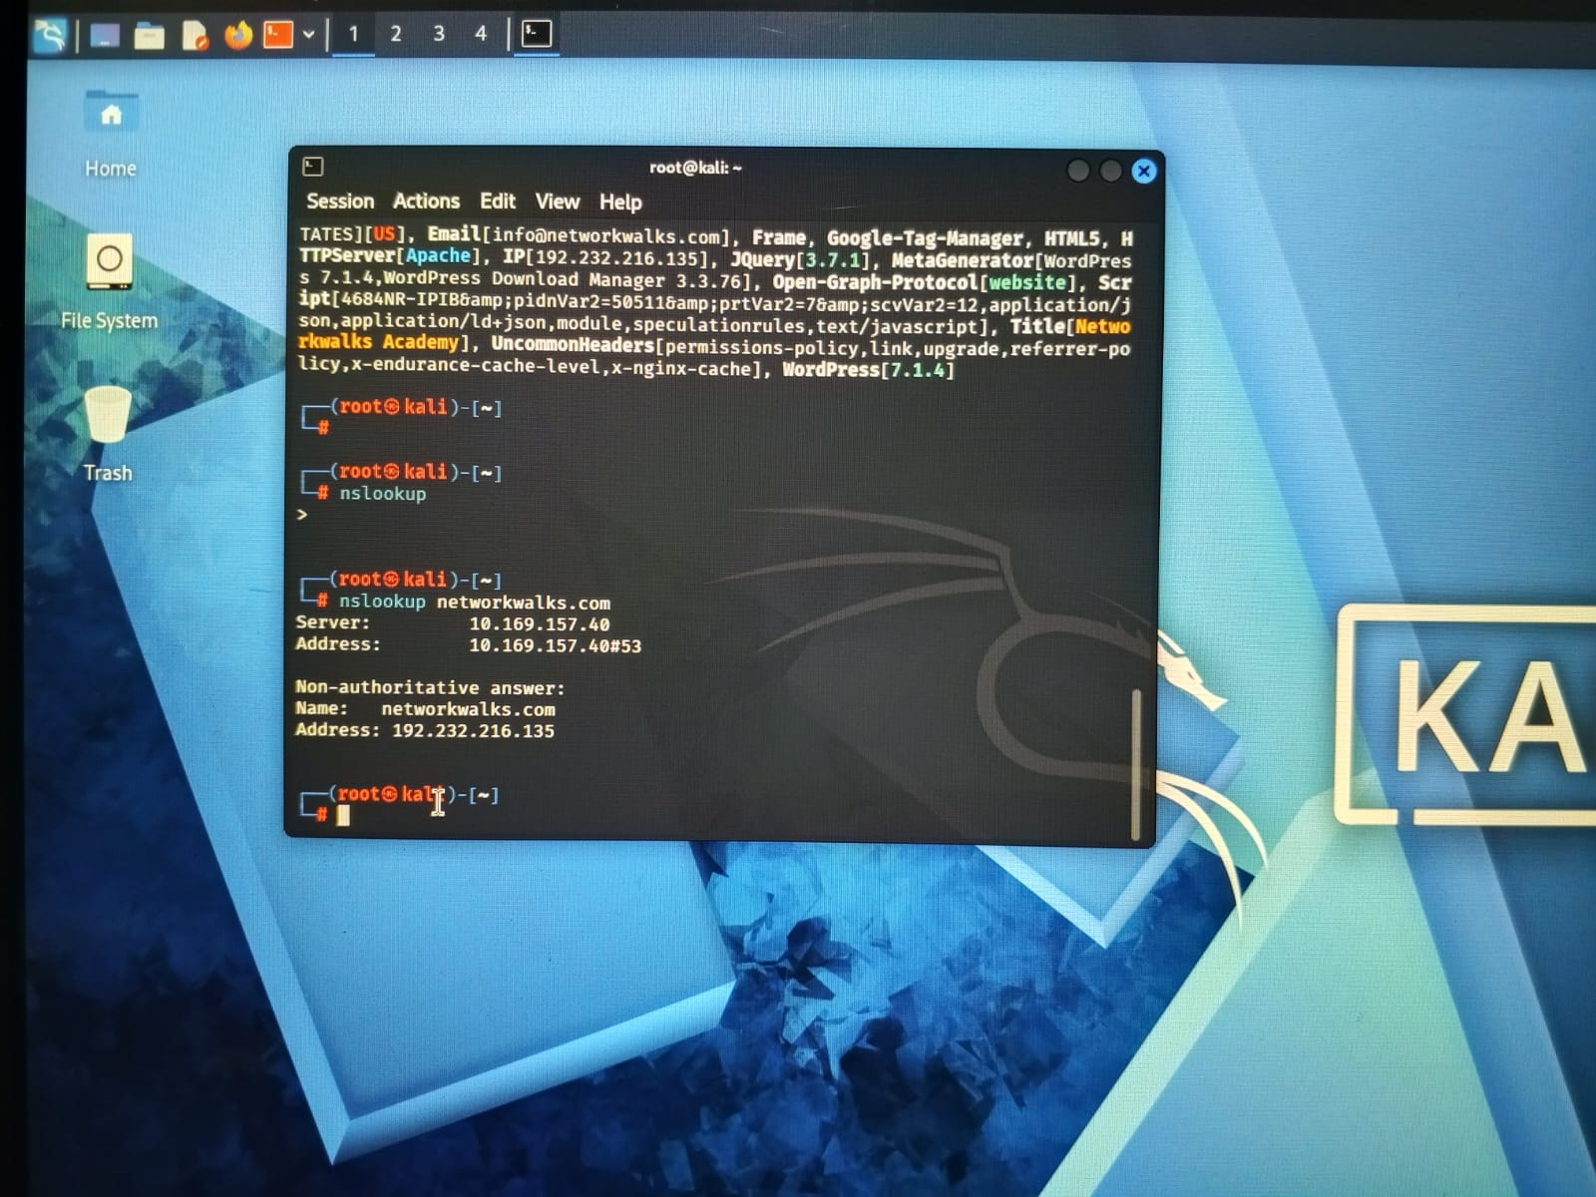

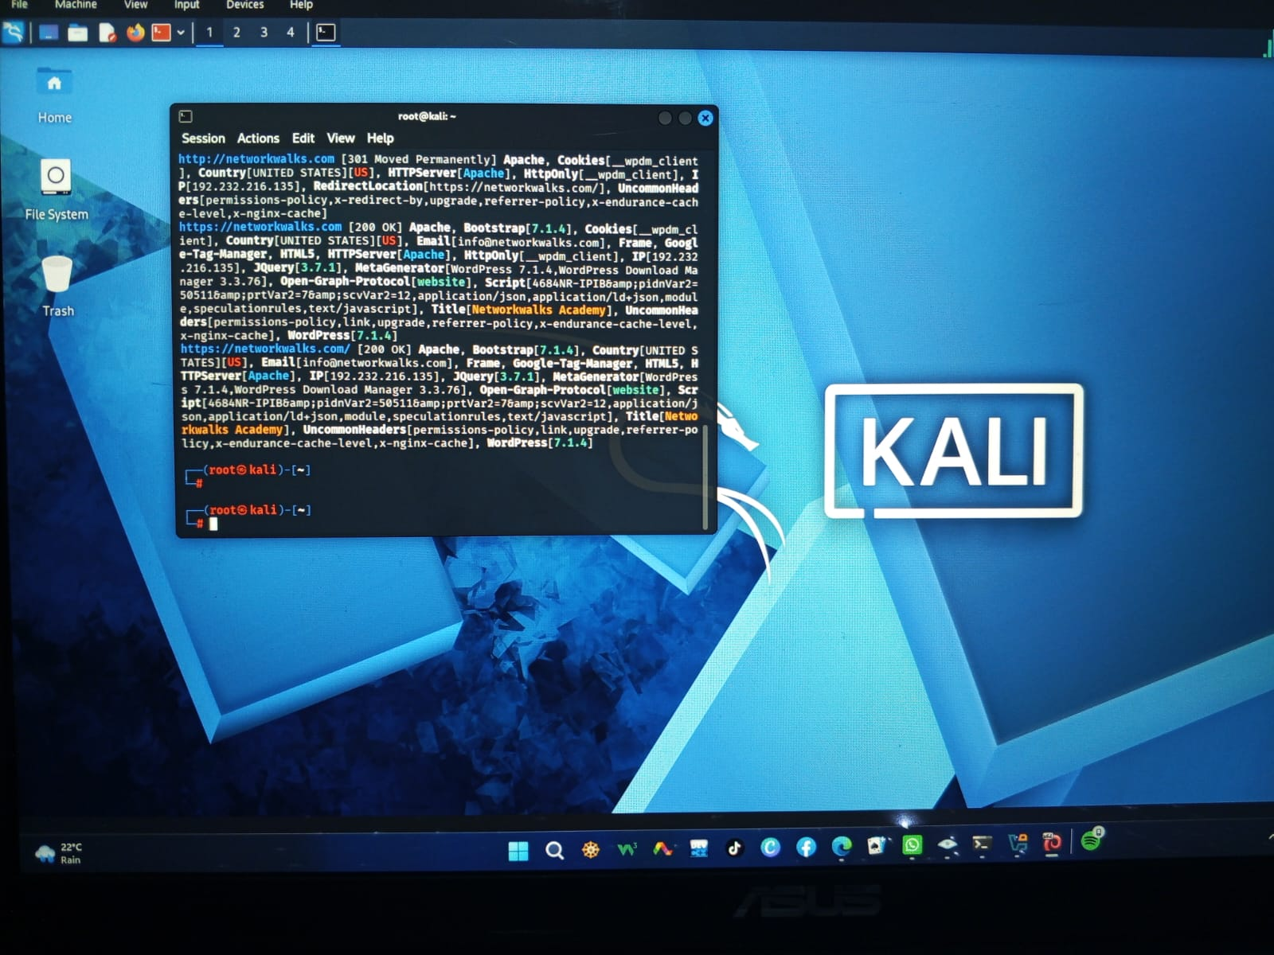

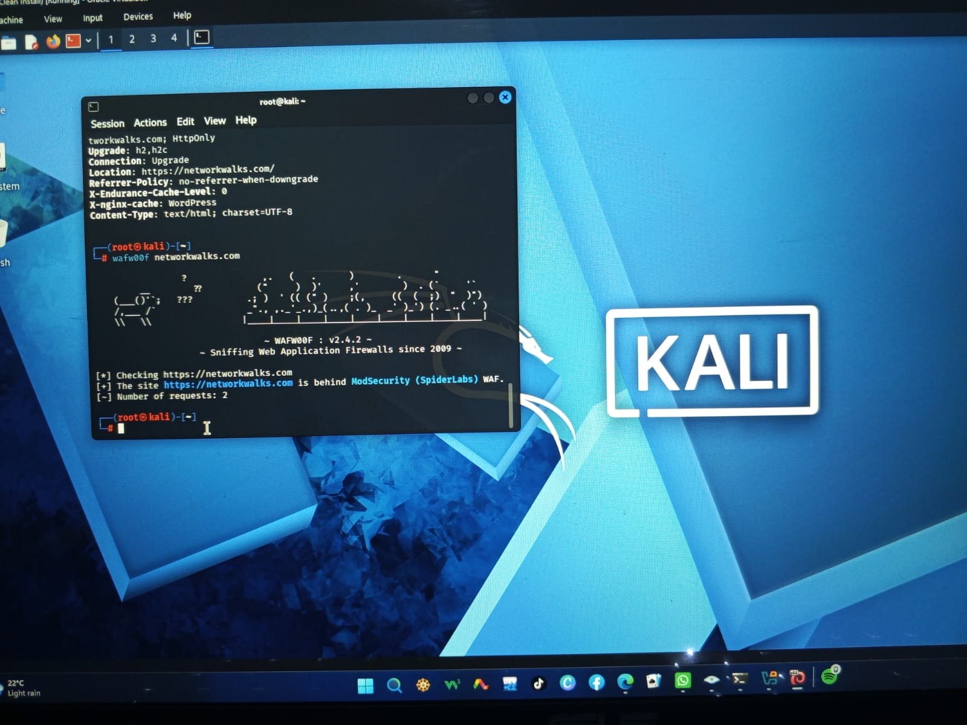

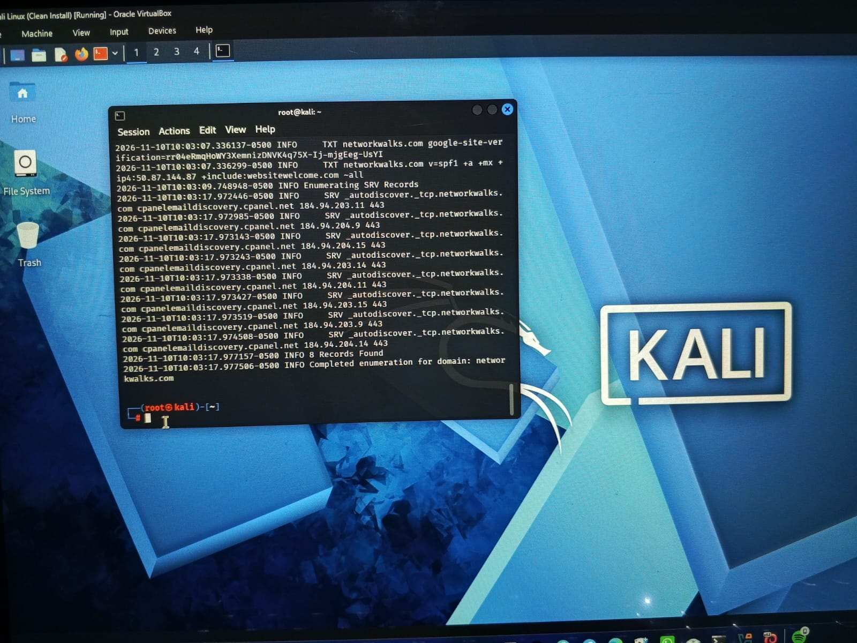

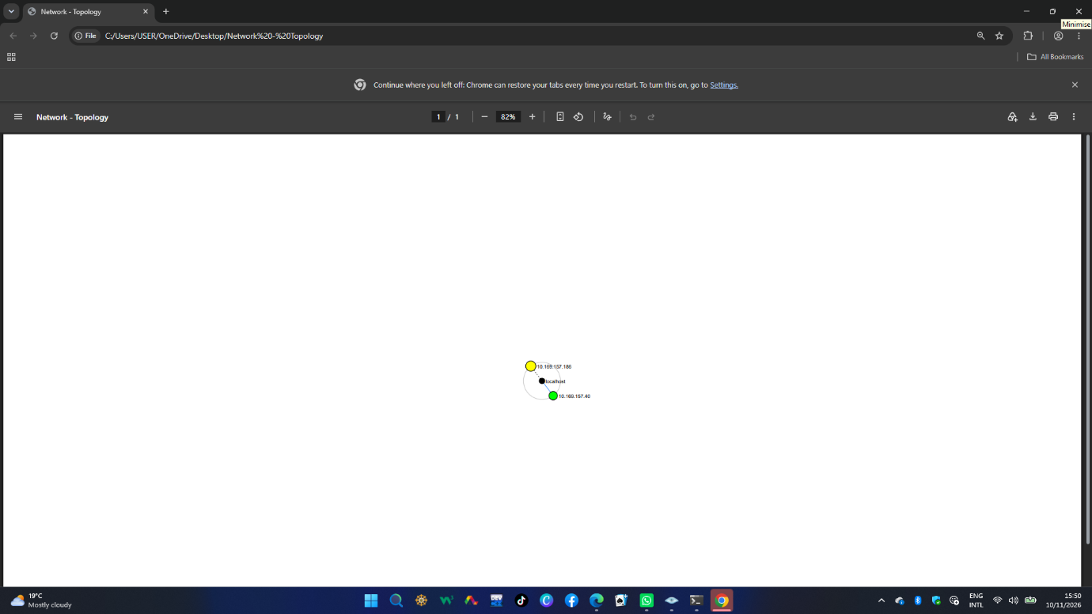

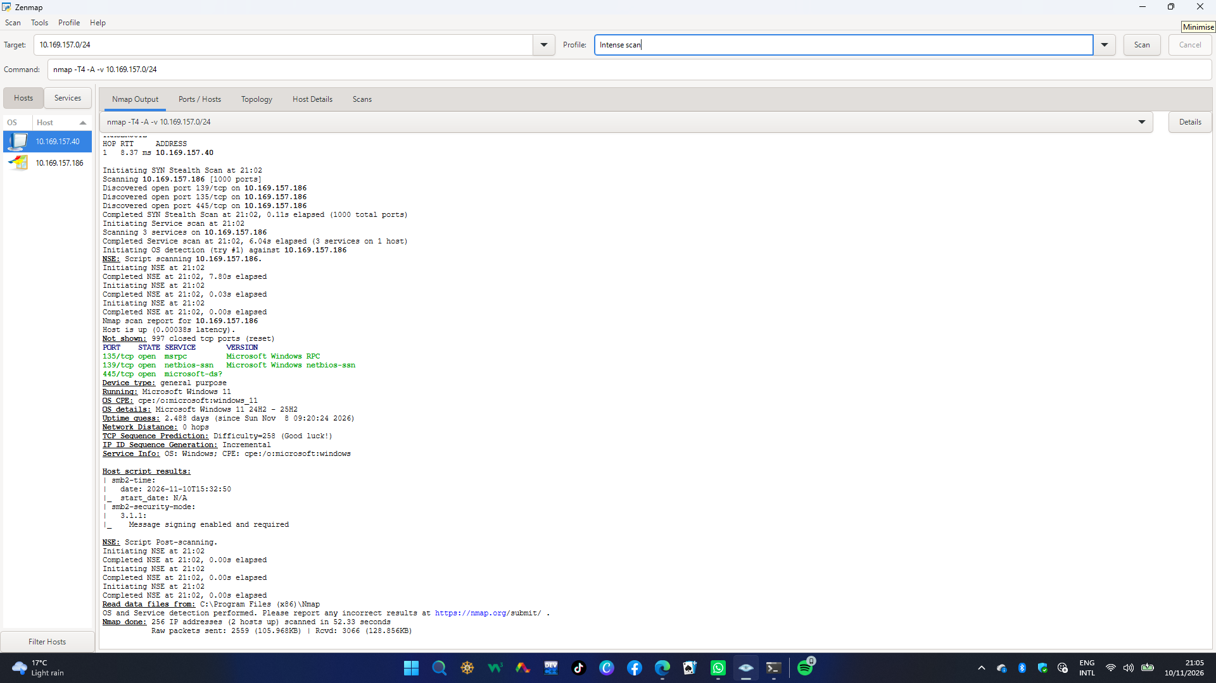

👤 Author Information

📌 LinkedIn : www.linkedin.com/in/kaveesha-heshani-7b942537b
- Name: Kaveesha Heshani Kumari
- Role: Cybersecurity Intern
- Program: Networkwalks Cybersecurity Program (Week 02 – B084K)
- Repository: GitHub

